Capstone SQL by Savan Patel
- Calculate the total number of customer encounters in the marketing campaign dataset
SELECT count(ID) from marketing_campaign_final
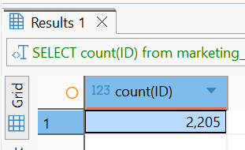
- Identify the top 10 most purchased products in the dataset, such as Wines, Meat Products, etc.
SELECT 'Wines' AS Category, SUM(MntWines) AS TotalAmount FROM marketing_campaign_final
UNION ALL
SELECT 'Fruits', SUM(MntFruits) FROM marketing_campaign_final
UNION ALL
SELECT 'Meat', SUM(MntMeatProducts) FROM marketing_campaign_final
UNION ALL
SELECT 'Fish', SUM(MntFishProducts) FROM marketing_campaign_final
UNION ALL
SELECT 'Sweets', SUM(MntSweetProducts) FROM marketing_campaign_final
UNION ALL
SELECT 'Gold', SUM(MntGoldProds) FROM marketing_campaign_final
ORDER BY TotalAmount DESC

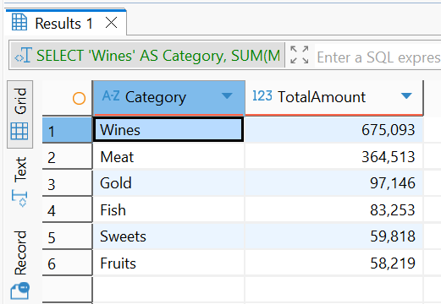

- Find the count of response values
SELECT Response, count(Response) from marketing_campaign_final
GROUP BY Response

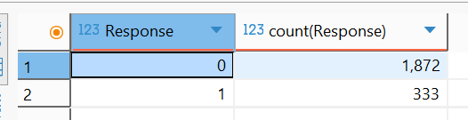
- Determine the distribution of customers based on their education level and marital status
SELECT Education, Marital_Status, count(ID) from marketing_campaign_final
GROUP BY Education, Marital_Status

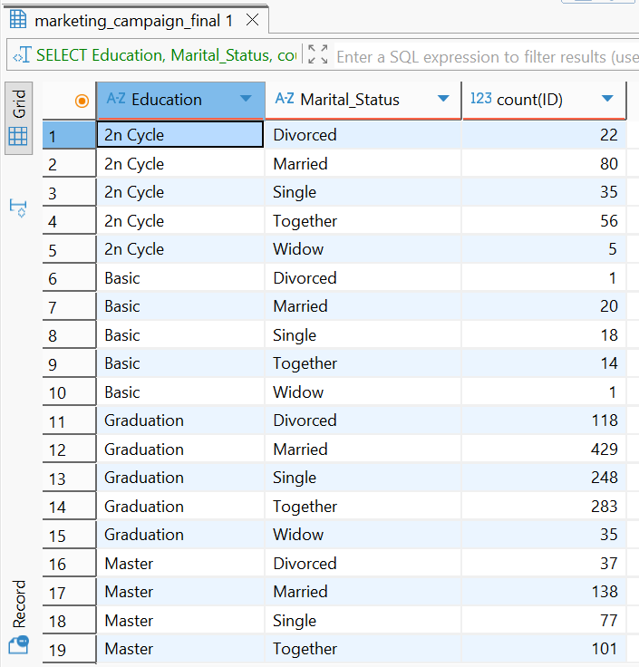

- Identify the average income of customers who participated in the marketing campaign
SELECT AVG(Income) from marketing_campaign_final
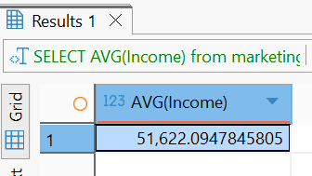
- Calculate the total number of promotions accepted by customers in each campaign
SELECT
SUM(AcceptedCmp1),
SUM(AcceptedCmp2),
SUM(AcceptedCmp3),
SUM(AcceptedCmp4),
SUM(AcceptedCmp5)
FROM
marketing_campaign_final

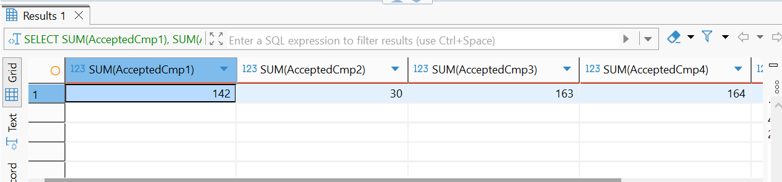
- Calculate the average number of children and teenagers in customers' households
SELECT ROUND(AVG(Kidhome),0), ROUND(AVG(Teenhome),0) from marketing_campaign_final
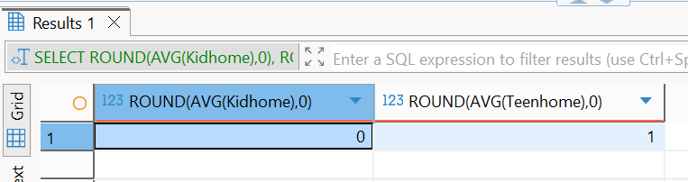

- Create Age_group columns then determine the average number of visits per month for customers in each age group
SELECT
Age,
CASE
WHEN Age BETWEEN 18 AND 25 THEN '18-25'
WHEN Age BETWEEN 26 AND 35 THEN '26-35'
WHEN Age BETWEEN 36 AND 45 THEN '36-45'
WHEN Age BETWEEN 46 AND 55 THEN '46-55'
ELSE '56+'
END AS Age_group,
ROUND(AVG(NumWebVisitsMonth), 0)
FROM
marketing_campaign_final
GROUP BY Age_group

